William Colon

4-1 Journal: Career Choice and Artifact Update

By incorporating my degree in computer science into my current line of work rather than beginning a new line of work, I am growing my skills and advancing my professional path. Throughout the course of this computer science program, I have learned abilities that have shown to be both excellent and invaluable. I am combining my understanding of computer science with my expertise working with computers for the past 25 years. In the next stage of my career as a computer and network technician in the school system, this will provide me with a crystal-clear sense of direction that I can follow easily. In addition, the fact that my degree has a concentration in cybersecurity will demonstrate that I am capable of leading a group of people in the planning and development of software and hardware.

I have selected the appointment system artifacts to be used for the project. Recommendations have been given to me regarding the artifacts that I have selected, and I am currently submitting the enhancement for the subsequent Category, which involves algorithms and data structures. To make the code more readable and editable by any programmer, I clean it up and include extra comments in the header and inline that explain the reasoning behind the decisions made about the code's overall operation. The eportfolio now includes my most recent posts. I still need to figure out the enhancement for Databases.

In order to improve the architecture of my project, I enhanced my algorithms and data structures. This will look through the system for any added appointments.

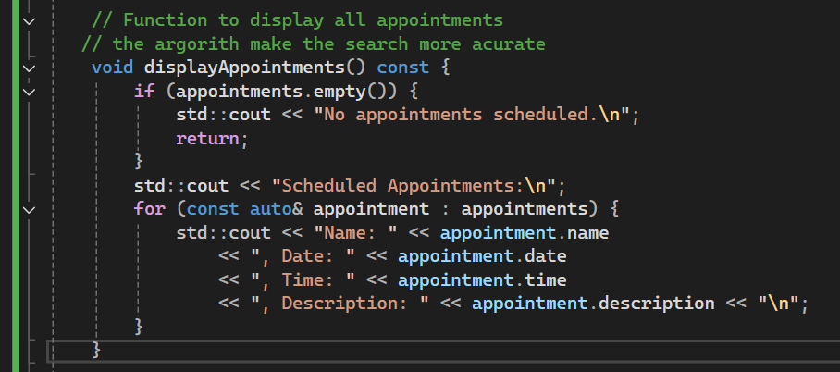

<https://github.com/williamcolon/IT-499-Code>